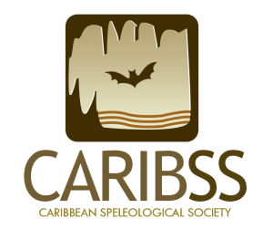

BONAIRE CAVES & KARST TOUR GUIDE COURSE

APPLICATION FORM

Full name:

Company name:

Position at company:

Email address:

Phone:

Please, provide PDF attachments to your application and answer the following questions:

(a) Copy of Bonaire “sedula” (applicant must be an adult).

(b) Proof of ownership/employment of/at company dedicated to tour guiding on Bonaire (e.g., business permit, Chamber of Commerce registration).

(c) Number of years operating as tour provider company on Bonaire.

(d) Describe your experience as cave tour guide operator, including number of guided visits to caves and sinkholes.

(e) Indicate which of the following equipment items are in possession of your company (we might ask to verify possession of the equipment):

● Rock climbing rope (Yes__ No__)
● Climbing harness (Yes__ No__)
● Biners (Yes__ No__)
● Hiking shoes (Yes__ No__)
● Dry headlamps (Yes__ No__) Number __
● Waterproof headlamps (Yes__ No__) Number __
● First aid kit (Yes__ No__)
● Rescue equipment (Yes__ No__)

Applications will go through a selection process and selected applicants will be informed to proceed with the full payment of the registration fee (US$ 325.00) one week after notification. Proof of payment must be received by May 31st, 2019.

Please, submit your application to: jafet.nassar@gmail.com
(Only fully completed application forms will be considered)
Application deadline: May 15th, 2019

